

Coverage

By: Eng. Islam Hamdy Mohamed
Guided By: Eng. Hassan Khaled

- Snippets for the implemented code
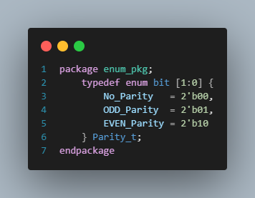

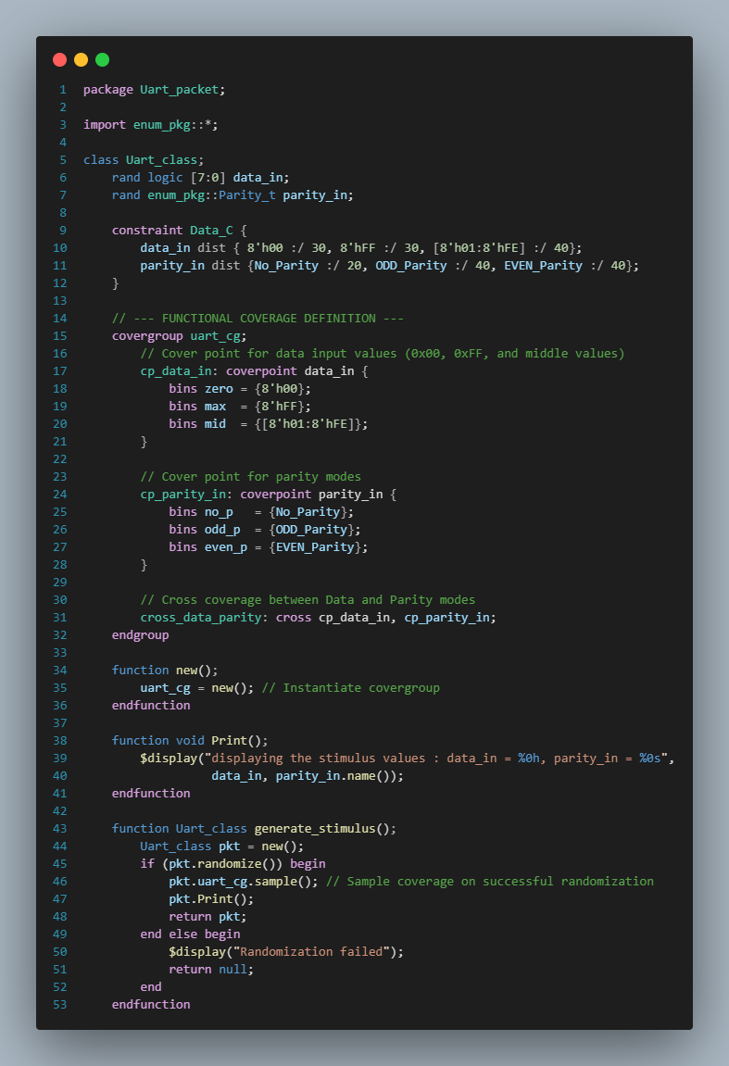
Figure 2 Uart_packet Class 1.1
Figure 1 Enum Package Definition (enum_pkg.sv)
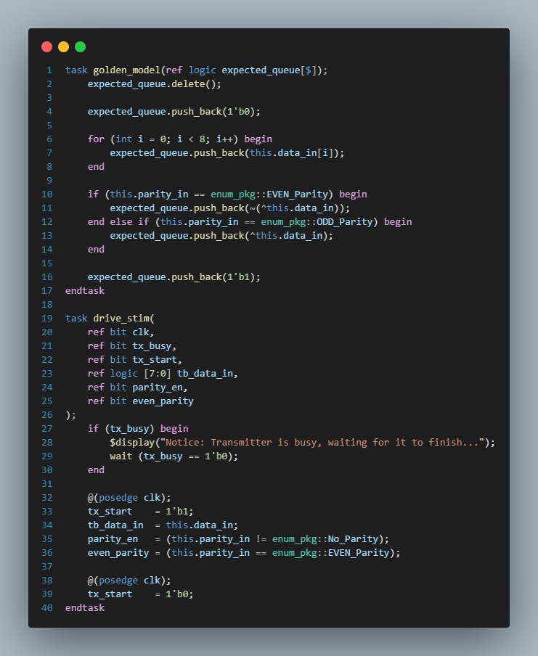

Figure 3 Uart_packet Class 1.2

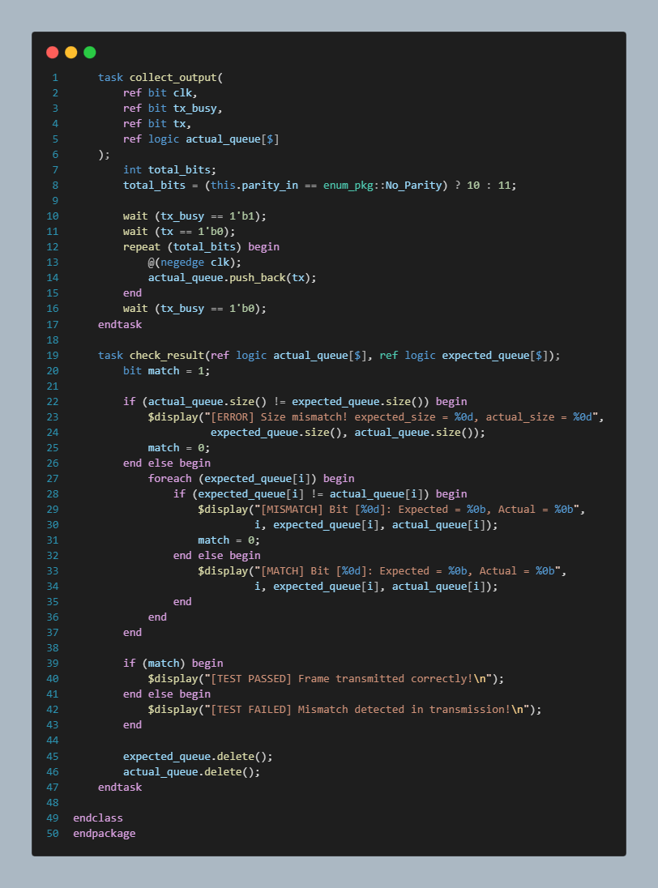

Figure 4 Uart_packet Class 1.3

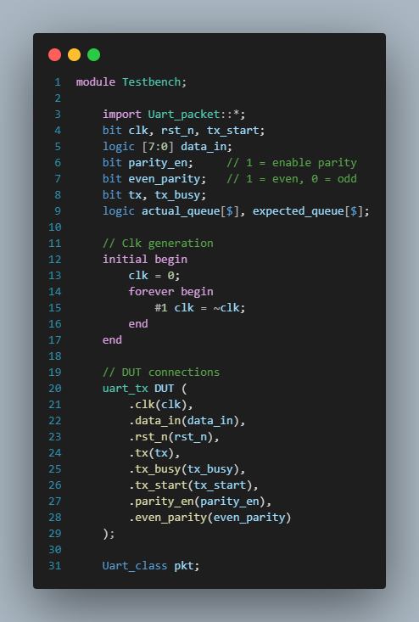

Figure 5 1.1 Top-Level Testbench Environment (Testbench.sv)

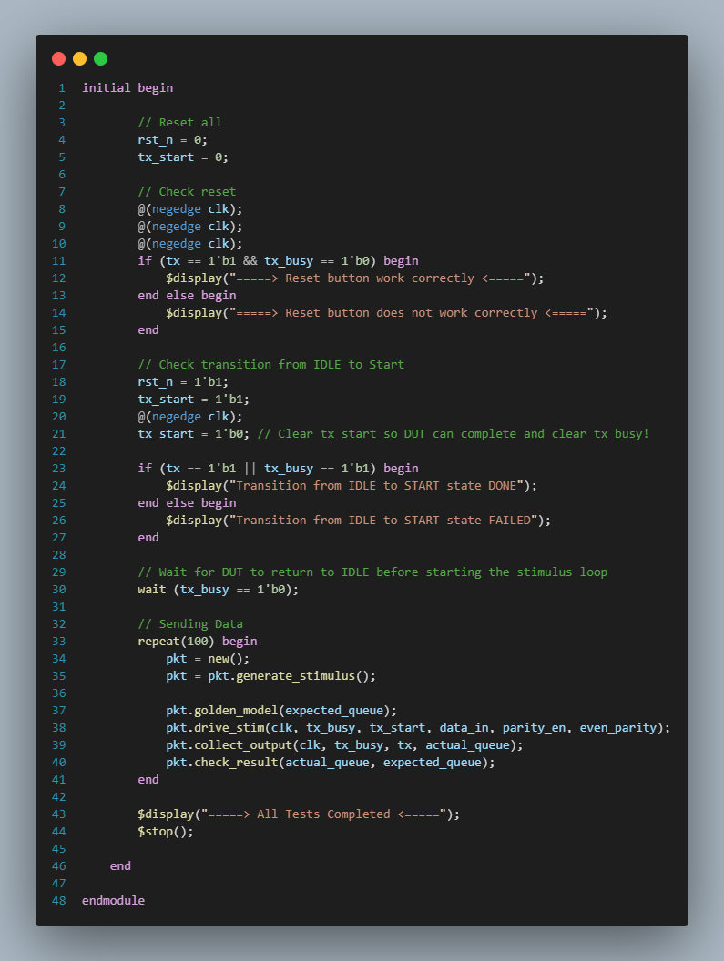

Figure 6 1.2 Top-Level Testbench Environment (Testbench.sv)
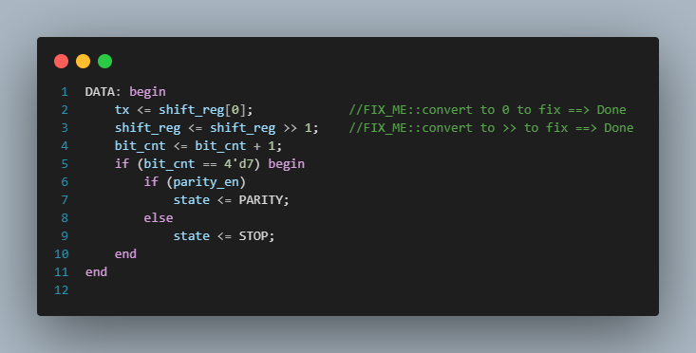

Figure 7 RTL Correction for Data Bit Order Inversion (DATA State)
- Description:
- Original Bug: The design was initially transmitting data MSB-first by driving tx <= shift_reg[7] and shifting left (shift_reg << 1), which violates the standard LSB-first UART transmission protocol.
- Applied Fix: Updated line 2 to transmit from bit 0 (tx <= shift_reg[0]) and line 3 to shift right (shift_reg <= shift_reg >> 1), ensuring correct LSB-to-MSB sequence.
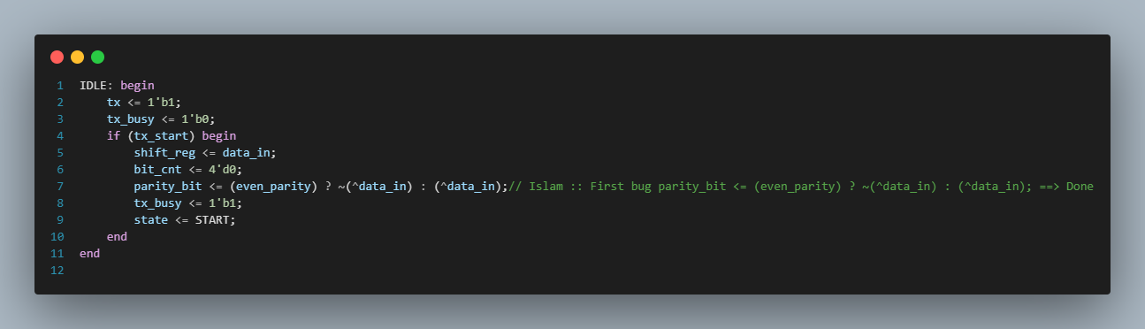
Figure 8 RTL Correction for Parity Bit Logic Inversion (IDLE State)

- Description:
- Original Bug: The conditional ternary logic inside the IDLE state inverted the parity bit calculation—generating odd parity when even_parity = 1 and even parity when even_parity = 0.
- Applied Fix: Corrected line 7 to parity_bit <= (even_parity) ? ~(^data_in) : (^data_in);, accurately generating Even parity for mode 1 and Odd parity for mode 0.

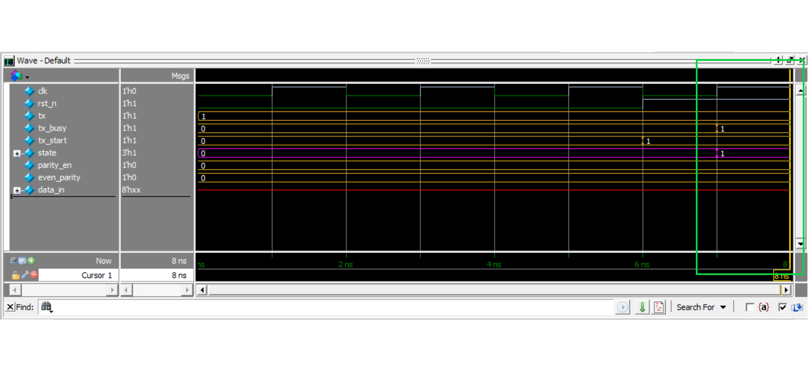
- 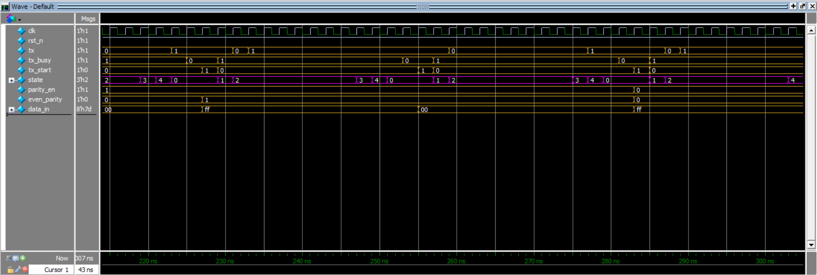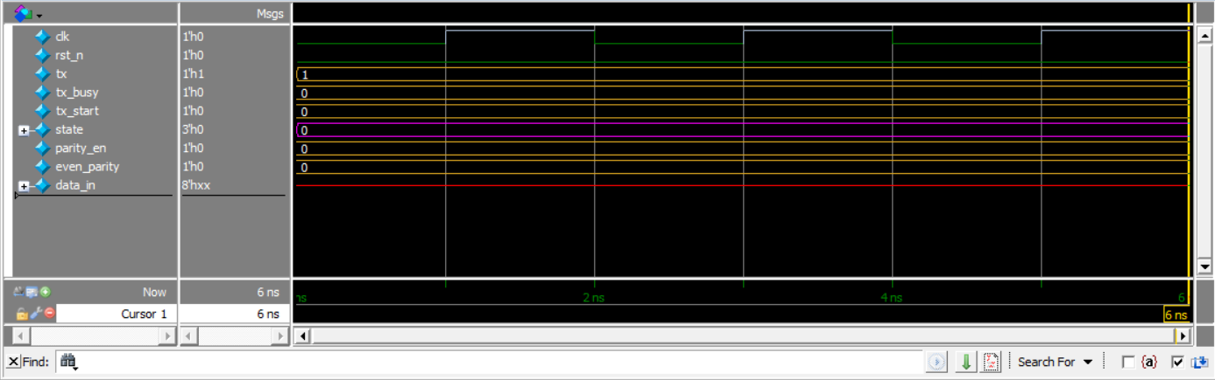Snippet for the waveform shows the different testcases
Figure 11 Waveform – Full FSM State Transitions Across Multiple Test Cases
Figure 10 Waveform – FSM Transition from IDLE to START State

Figure 9 Waveform – Reset Assertion Verification (Active-Low Reset)

- Snippets for the logs show the all printed values.
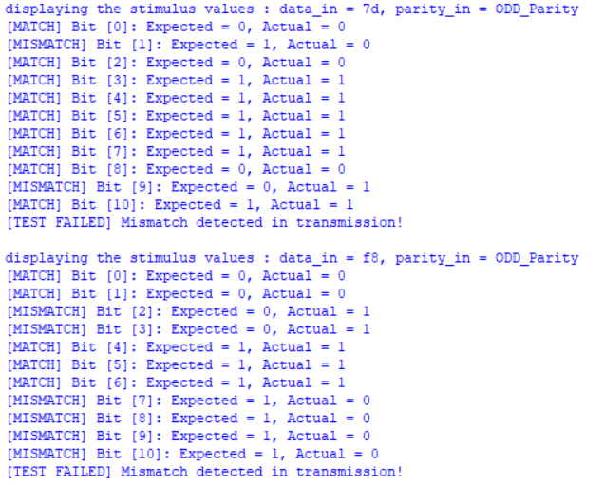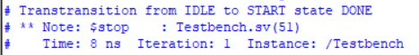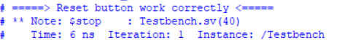
Figure 14 Log shows a missmatch in the transmission
Figure 13 Log(Transition From IDLE to Start)
Figure 12 Log(Check the reset button)

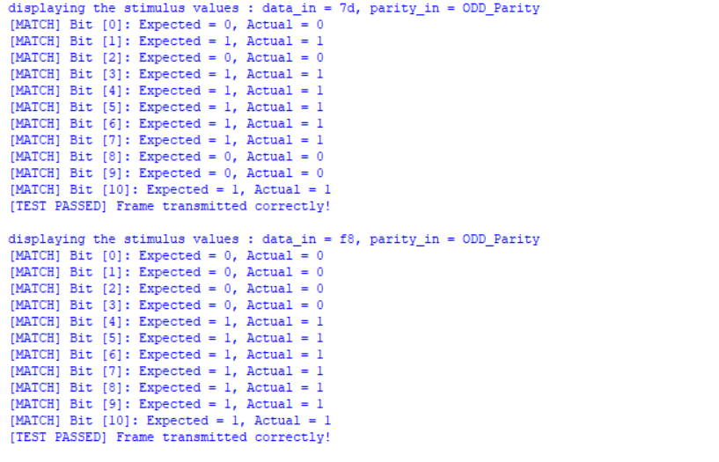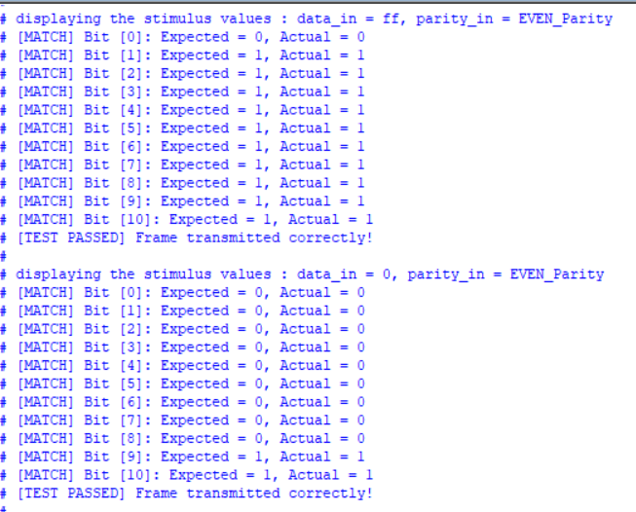
Figure 16 Log for different data with different parity bits
Figure 15 Log for testing the corners

- Snippet for Do file you have used for automating the process.
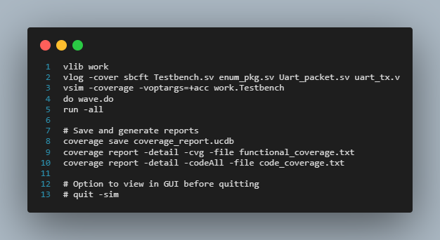

Figure 17 Do file used for automating the process

- Summary of Found Bugs & Fixes:
- Data Bit Order Inversion (MSB-First Transmission)
- Issue: The original RTL transmitted data bits MSB-first (shift_reg[7] with shift_reg << 1), violating standard LSB-first UART protocol rules.
- Resolution: Updated the DATA state logic to send LSB-first using tx <= shift_reg[0] and shift_reg <= shift_reg >> 1.
- Parity Bit Logic Inversion
- Issue: The parity generation logic was inverted in the IDLE state, producing Odd parity when Even mode was selected and vice versa.
- Resolution: Corrected the parity ternary statement to parity_bit <= (even_parity) ? ~(^data_in) : (^data_in).

- Code Coverage
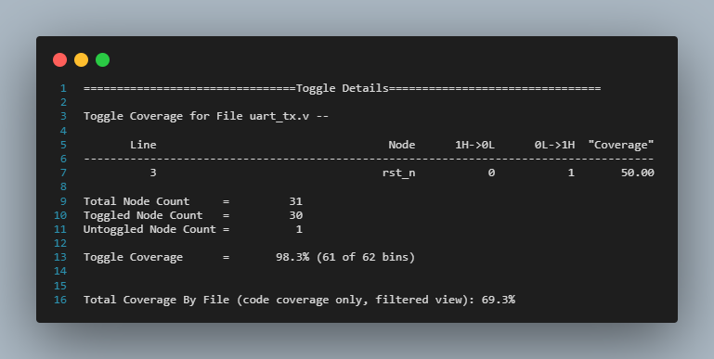

Figure 18 End of code coverage report showing 98.3 % coverage

- Note : code_coverage.txt file was added to the .rar file

- Functional Coverage
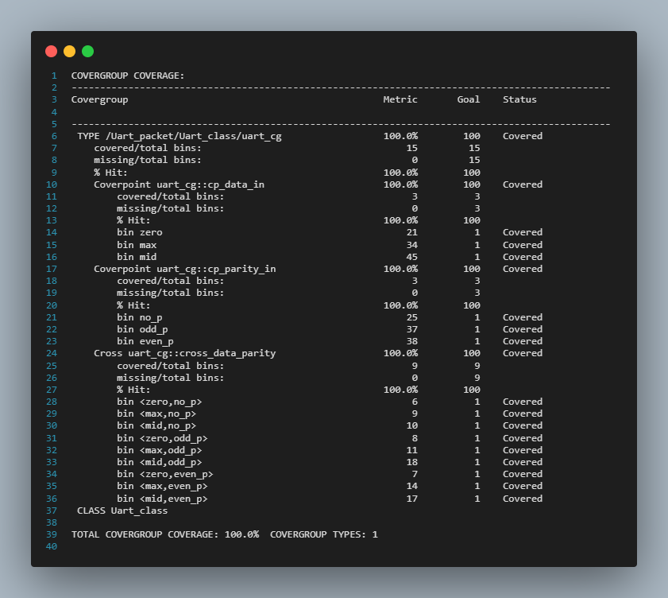
Figure 19 Functional Coverage report showing 100% coverage

- Note : functional_coverage.txt was added to the .rar file

